Announcing the 2024-2025

Jr. High Volleyball

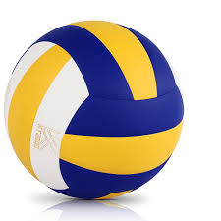

8th Grade Players and Captains

Captains:

Cally Ishman

&

Mia Myers

Players:

Ella Burchell

Anna DiLembo

Mae Esguerra

Randi Flowers

Aryanna Kinard

Mia Lazzaro

Crisanna Lee

Ryleigh Loving

Alicia Martin

Ariyah Moon

Kyliee Mulverhill

CONGRATULATIONS!!!